How to design any Spring /ORM Application

1. Configure Maven Project
2. Add required plugins
   1. War plugin
   2. Compiler plugin

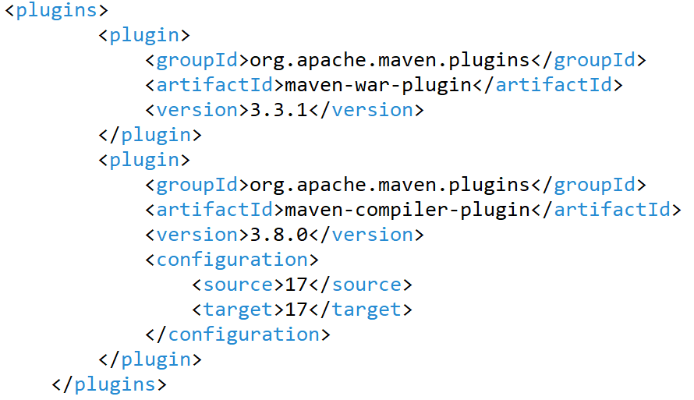

1. Add required dependencies
   1. Servlet-API
   2. JSP-API
   3. Spring-webmvc
   4. Spring-orm
   5. Commons-dbcp
   6. Hibernate-Core
   7. Mysql-connector
2. Configure below xml file to WEB-INF/ folder
   1. Web.xml
   2. Dispatcher-servlet.xml
   3. Create /WEB-INF/views folder
3. Spring MVC Project Structure Diagram

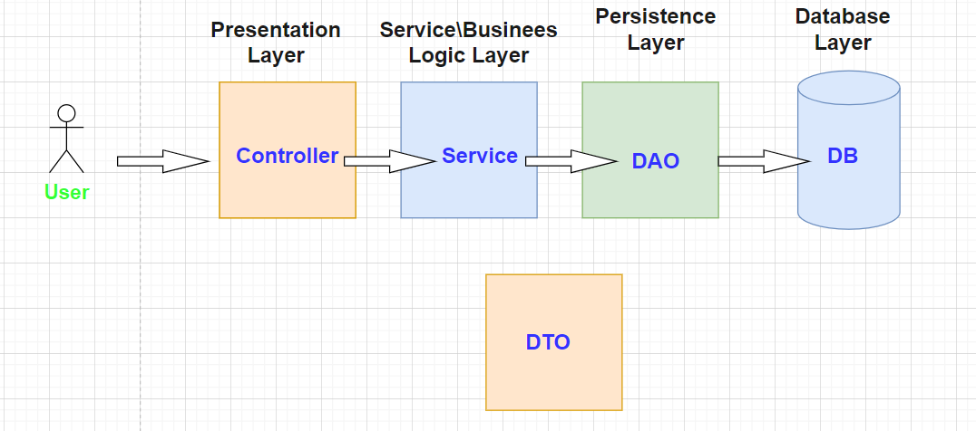

1. Create Folder Structure
   1. Entity|Model|Domain
   2. DAO(Data-access-object)
   3. Service(Business logic)
   4. Controller
   5. Test(optional)
2. Add classes into folder structure
   1. Entity class

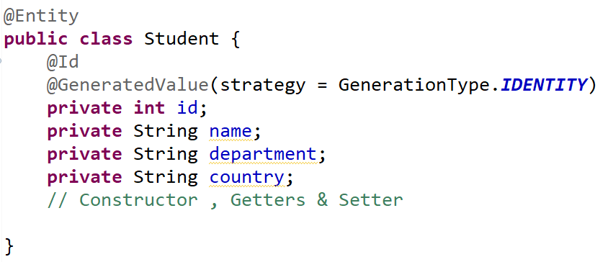

* 1. DAO interface

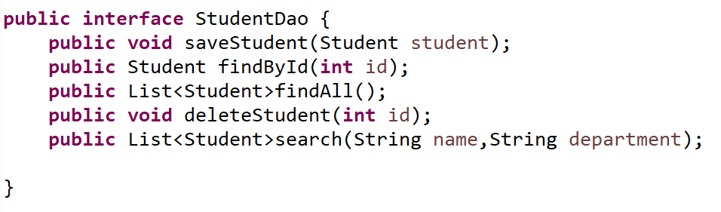

* 1. DAO implementations

1. Controller class
   1. Check with Dummy output and ensure complete flow from user request to response.
   2. /WEB-INF/views folder/student-list.jsp
2. Add some bootstrap in views
   1. Index.jsp
      1. Go to Bootstrap 4 Containers

https://www.w3schools.com/bootstrap4/bootstrap_container

* + 1. Heading
    2. HR
    3. Subheading

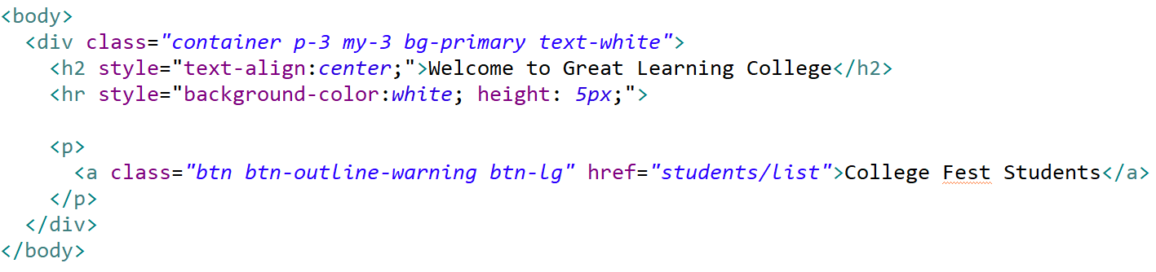

* 1. Create student-list.jsp
     1. Add Link for display Participants
     2. Create Dummy table

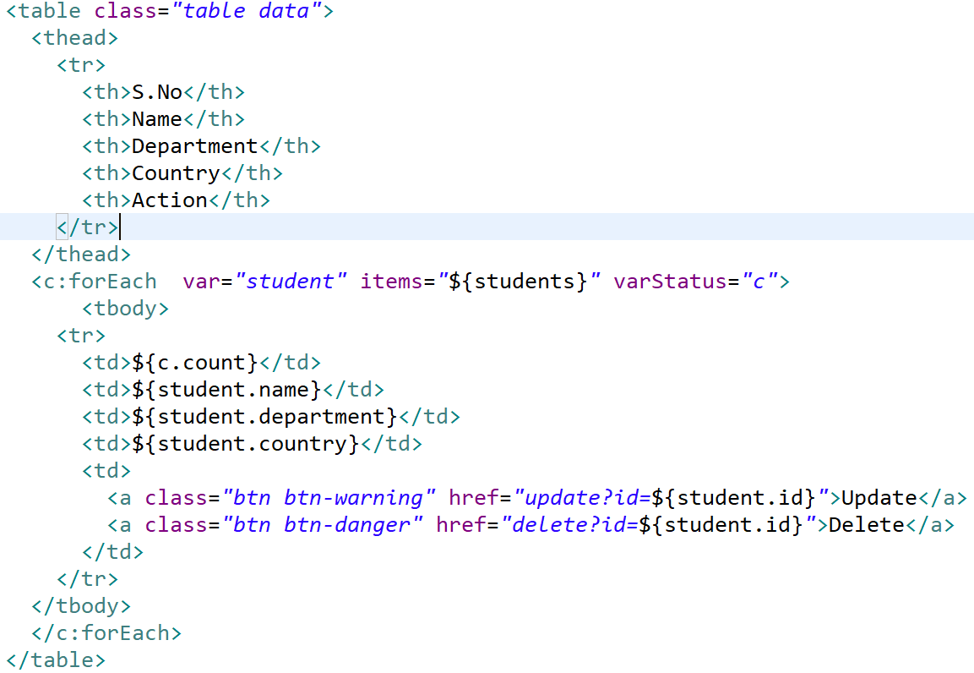

* 1. Create student-form.jsp

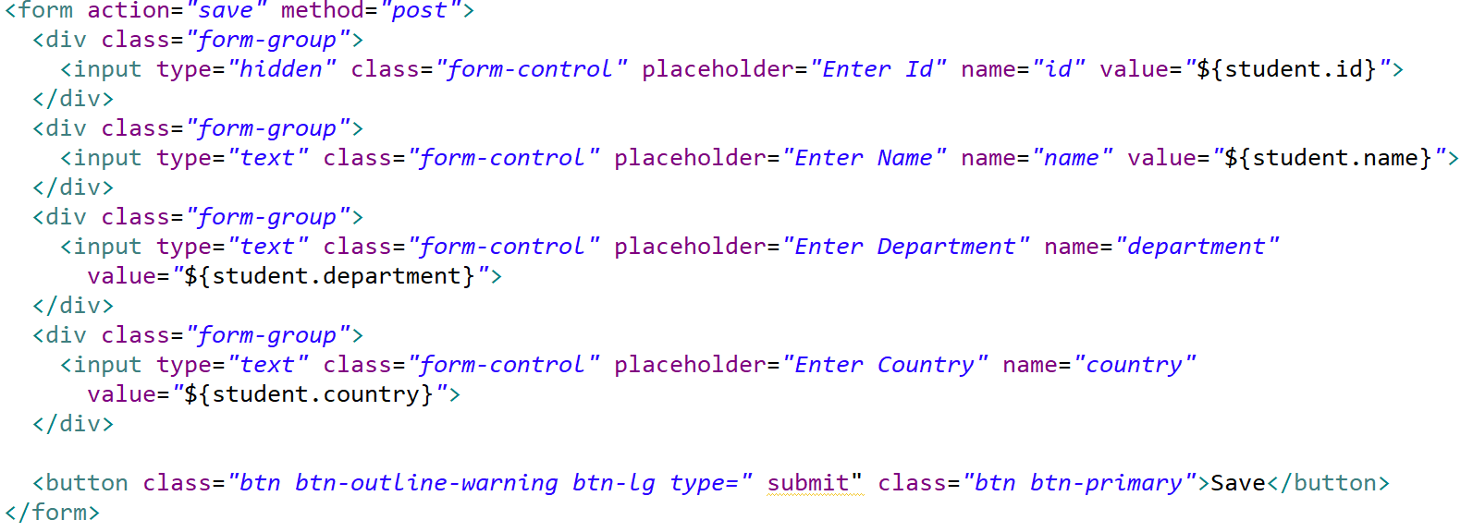

1. Create Student Controller class
   1. Method for display student list & mapping to display

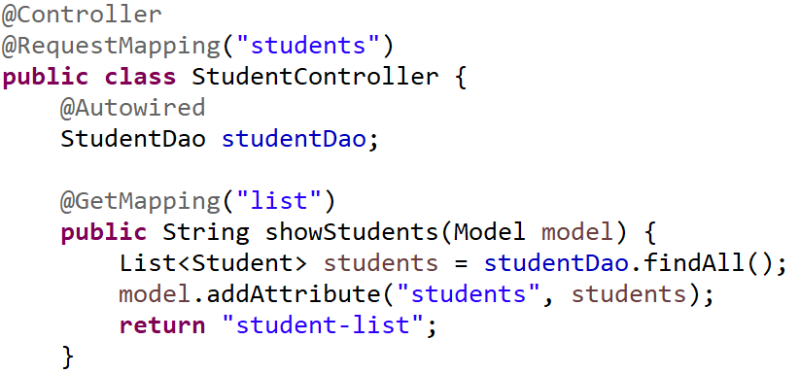

* 1. Method for show student form

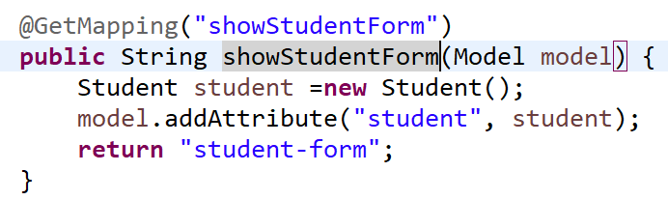

* 1. Method for save student

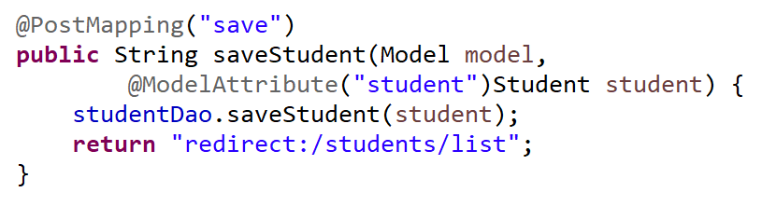

* 1. Method for update student

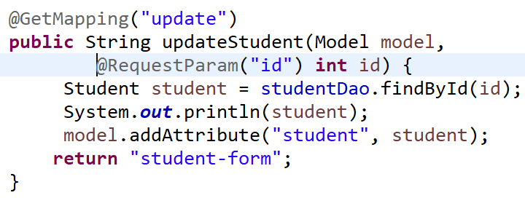

* 1. Method of delete student

